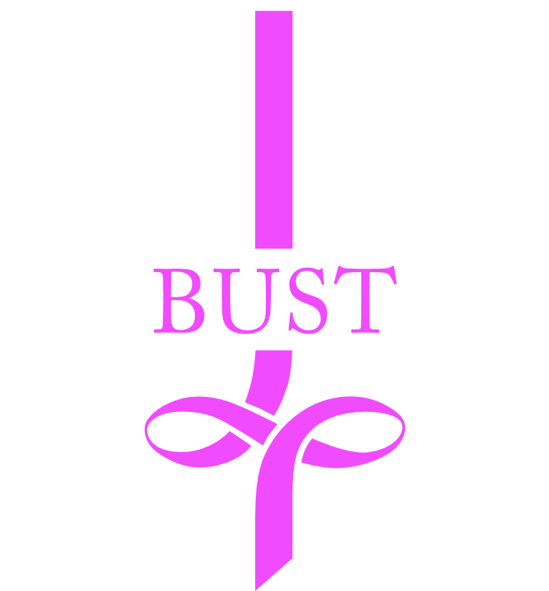

Breastcancer Unit Support Trust
supporting Bristol Breast Care Centre
at Southmead Hospital

Let’s stay in touch ……….

We would love to keep you up to date with information about BUST and the Bristol Breast Care Centre at Southmead. We have a members group which meets quarterly at Southmead and at each event there are invited speakers. If you would like us to send you quarterly newsletters and keep you informed about our campaigns, research and fundraising, please complete the form below to comply with the current GDPR. Your details will never be shared with anyone else now or in the future. Please tick yes or no to each instance. You may change your decision at any time by contacting BUST.

Post Yes No

Email Yes No

Telephone Yes No

Name …………………………………………………………………………………………………

Address……………………………………………………………………………………………….

…………………………………………………………………………………………………………

Postcode………………………………………………………………Date ………………………

Email…………………………………………………………………………………………………..
(Please print clearly)

Telephone…………………………………………………………………………………………….

Mobile Phone…………………………………………………………………………………………

Please complete and return within one month of receipt.

Please email the form to:

jacquelinerjones19@gmail.com

Or alternatively post to Jackie Jones, 19 Blackberry Drive, Frampton Cotterell, Bristol BS36 2SL

Breast-cancer Unit Support Trust
at The Breast Care Centre, Southmead Hospital, North Bristol NHS Trust, Bristol BS10 5NB Charity No. 1117508
www.bustbristol.co.uk
Tel: 07712 114774

